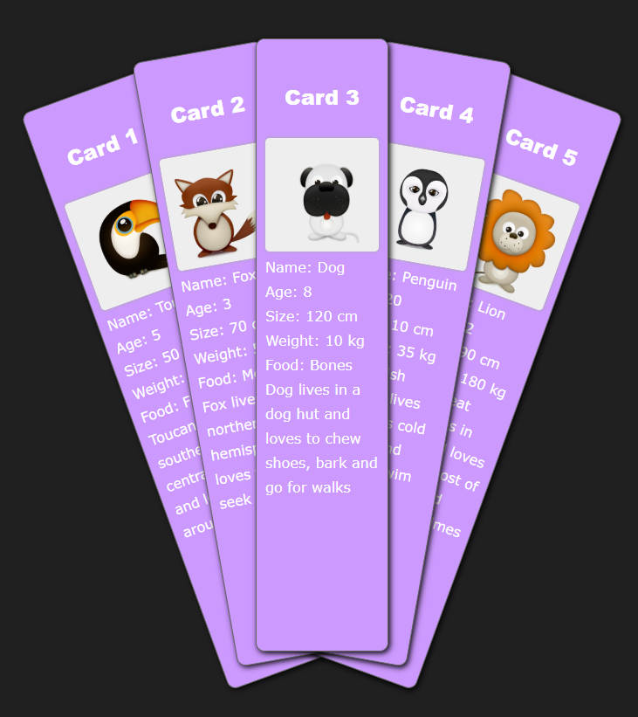

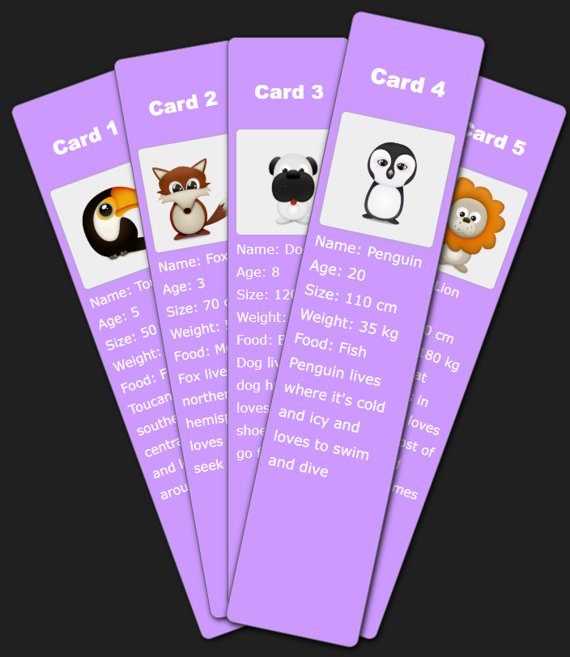

<!DOCTYPE html PUBLIC "-//W3C//DTD XHTML 1.0 Transitional//EN" "http://www.w3.org/TR/xhtml1/DTD/xhtml1-transitional.dtd">

<html xmlns="http://www.w3.org/1999/xhtml">

<head>

<meta http-equiv="Content-Type" content="text/html; charset=utf-8" />

<title>Documento sin tÃ­tulo</title>

</head>

<body>

<div id="wrapper">

<ul id="index_cards">

<li id="card-1">

<h3>Card 1</h3>

<img src="IMAGES/t9tuqui_trans.png" height="130" width="130" alt="Toucan" />

<p>Name: Toucan<br />

Age: 5<br />

Size: 50 cm<br />

Weight: 600 g<br />

Food: Fruit<br />

Toucan lives in southern and central America and loves to fly around</p>

</li>

<li id="card-2">

<h3>Card 2</h3>

<img src="IMAGES/t9foxy_trans.png" height="130" width="130" alt="Fox" />

<p>Name: Fox<br />

Age: 3<br />

Size: 70 cm<br />

Weight: 5.5 kg<br />

Food: Meat<br />

Fox lives in the northern hemisphere and loves to play seek and hide</p>

</li>

<li id="card-3">

<h3>Card 3</h3>

<img src="IMAGES/t9dog2_trans.png" height="130" width="130" alt="Dog" />

<p>Name: Dog<br />

Age: 8<br />

Size: 120 cm<br />

Weight: 10 kg<br />

Food: Bones<br />

Dog lives in a dog hut and loves to chew shoes, bark and go for walks</p>

</li>

<li id="card-4">

<h3>Card 4</h3>

<img src="IMAGES/t9penguino_trans.png" height="130" width="130" alt="Penguin" />

<p>Name: Penguin<br />

Age: 20<br />

Size: 110 cm<br />

Weight: 35 kg<br />

Food: Fish<br />

Penguin lives where it's cold and icy and loves to swim and dive</p>

</li>

<li id="card-5">

<h3>Card 5</h3>

<img src="IMAGES/t9lion_trans.png" height="130" width="130" alt="Lion" />

<p>Name: Lion<br />

Age: 12<br />

Size: 190 cm<br />

Weight: 180 kg<br />

Food: Meat<br />

Lions lives in Africa and loves to sleep most of the day and hunt sometimes</p>

</li>

</ul>

</div>

</body>

</html>

Dada la siguiente pagina crea los estilos necesarios para que los elementos se c oloquen como en la primera imagen y para que al ponernos con el raton sobre una de las cards se ‘ponga por encima de las demás y se incremente la inclinación (una transformación de escala de 1 a 1.1 y de rotación de 2 grados y de z index)